How to build a tide gauge

ORE 203L

Helpful links:

<https://learn.adafruit.com/adafruit-feather-32u4-adalogger>

<https://www.maxbotix.com/documents/LV-MaxSonar-EZ_Datasheet.pdf>

<https://learn.adafruit.com/adafruit-oled-featherwing/usage>

<https://www.arduino.cc/en/Guide/Introduction>

[How to Use a Breadboard - learn.sparkfun.com](https://learn.sparkfun.com/tutorials/how-to-use-a-breadboard/all)

1. Assemble all the bits and pieces
   1. Insert the feather adalogger board into the breadboard
   2. Insert the micro SD card into the holder
   3. Insert the USB cord to power the board (we will use batteries later for deployment)
2. Download Arduino IDE: <https://www.arduino.cc/en/Main/Software>
3. You will need to add a few libraries and select the proper board/port
   1. Go to Sketch 🡪 include library 🡪 manage libraries
   2. Type in ‘adafruit ssd1306’
   3. Install library
   4. Go back to manage libraries
   5. Type in ‘adafruit gfx’
   6. Install library
   7. Make sure to plug in your feather board into your computer
   8. Go to Tools 🡪 board 🡪 Adafruit Circuit Playground
   9. Go to Tools 🡪 Port 🡪 (select appropriate com) *if you need help figuring this out let me know (you can figure out which com to select by opening up device manager on your computer or you can guess and see which one works!)
4. Let’s write some code! Make the LEDs blink
   1. Choose a pin (9-12) to write high/low (turn LED on/off)
   2. Insert the LED into the breadboard so that the long leg is connected to the pin and the short leg is connected to ground (*note: typically, a resistor would be used in the circuit here but it will be omitted for simplicity in this exercise)
   3. You can use the spare black wire to connect the GND pin on the board to the – strip on the breadboard and then place one leg of the LED on the – strip and the other leg adjacent to your selected pin

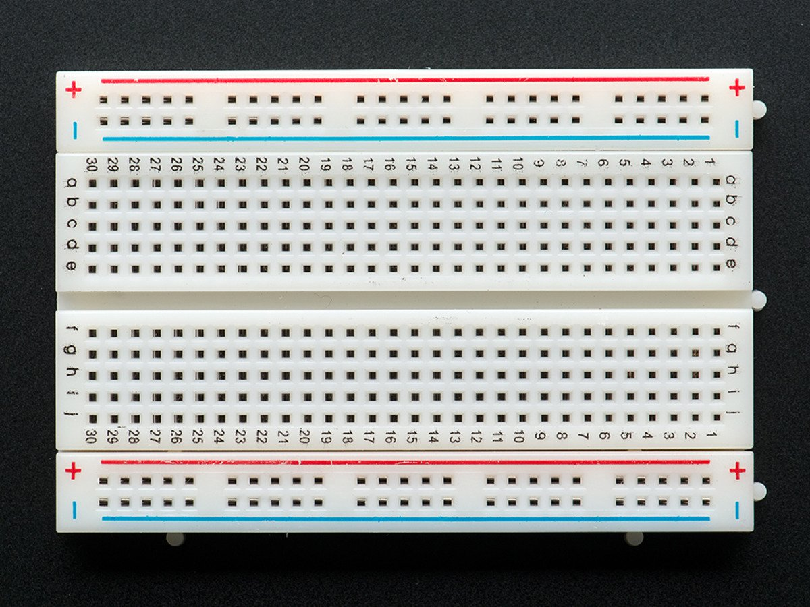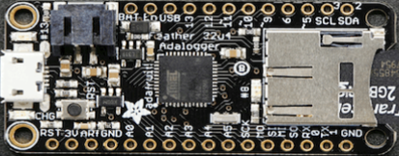

* 1. Open up the ‘LED_blink’ sketch
  2. Upload it to your board by clicking on 🡪 button upper left
  3. Now you should see the LED blinking
  4. Next add another LED to another pin and change the rate of blinking by changing the delay in your sketch

1. Adding the range finder
   1. Now take the ultrasonic range finder with 3 wires attached
   2. Black = ground, red = power, blue = signal
   3. Plug the black wire into the breadboard connected to ground (GND or -)
   4. Plug the red wire into the breadboard connected to the 3V
   5. Plug the blue wire into the breadboard connected to A1



1. Adding the screen
   1. Now take your feather board with a screen and press it on top of the adalogger on your breadboard
   2. Upload the Arduino sketch titled ‘Write_to_screen’
   3. You can change what is displayed on the screen by typing a new message in the sketch where it says “display.println("**ORE 203L!**");” and upload again
2. Let’s display the distance!
   1. Open and upload the Arduino sketch ‘tide_gauge’
   2. You should see the distance displayed on your screen
   3. Try placing objects in front of your rangefinder at different distances. Does the number change?
3. Get ready for deployment (we will do this again at the Marine Center)
   1. Now that you are familiar with how the sensor works and how to communicate with it let’s get it ready for deployment in the field
   2. Open the Arduino sketch ‘Full_tide_gauge’
   3. Set the delay to your desired value (line 97 at bottom)
   4. Choose the name of the file you want the data to be saved to on the SD card (line 74)
   5. Assemble the battery pack and plug it in to the board
   6. Try removing the usb cable and make sure the board still is powered
   7. Turn everything off and we are almost ready to deploy!

When we get to the Marine Center, we will assemble the sensors in a water-resistant container and perform a calibration. Please make sure to switch your battery packs off and store the electronics in one of the bags I gave to keep it clean/dust free.